CS 255 System Design Document Template

UML Use Case Diagram
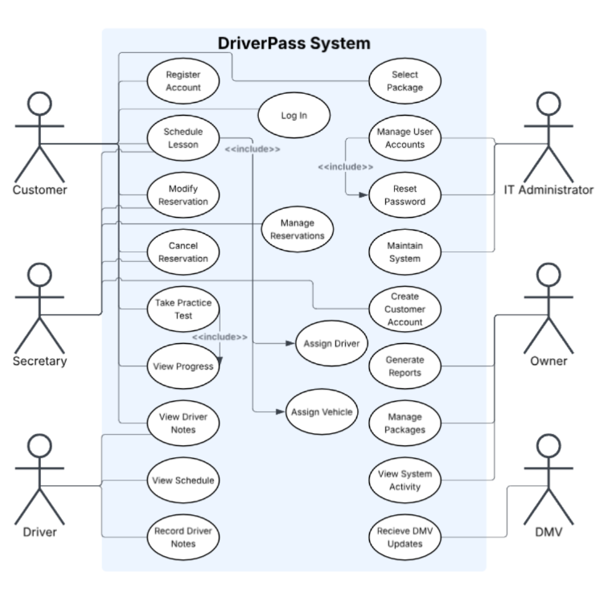

UML Activity Diagram 1
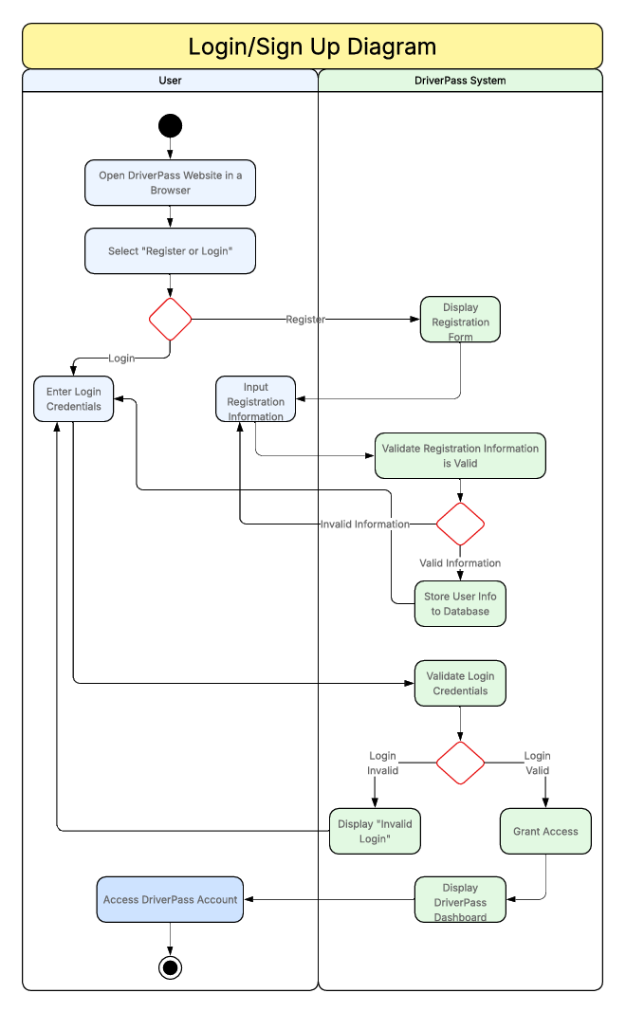

UML Activity Diagram 2
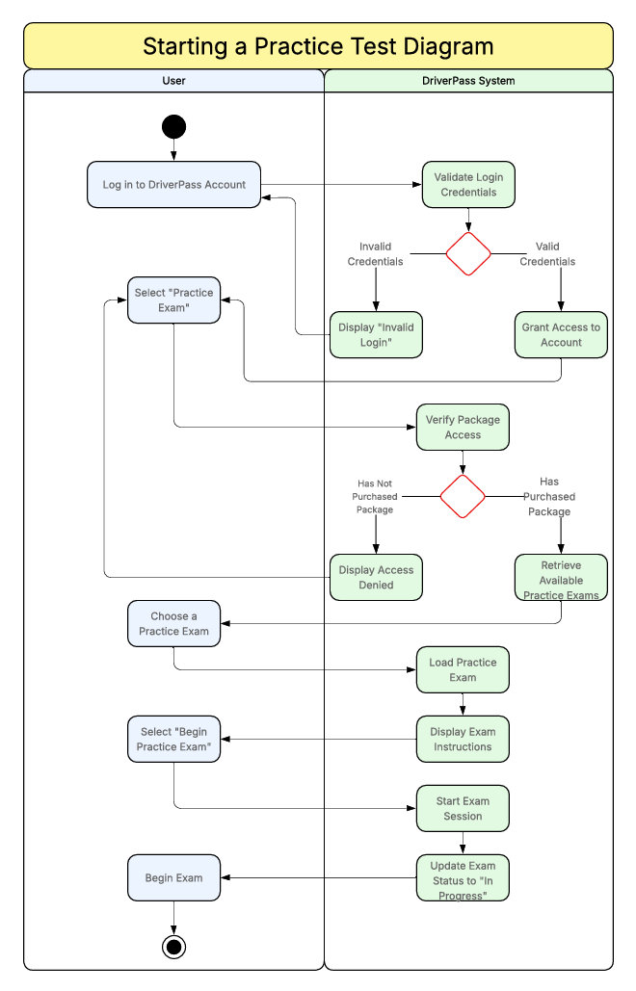

UML Sequence Diagram
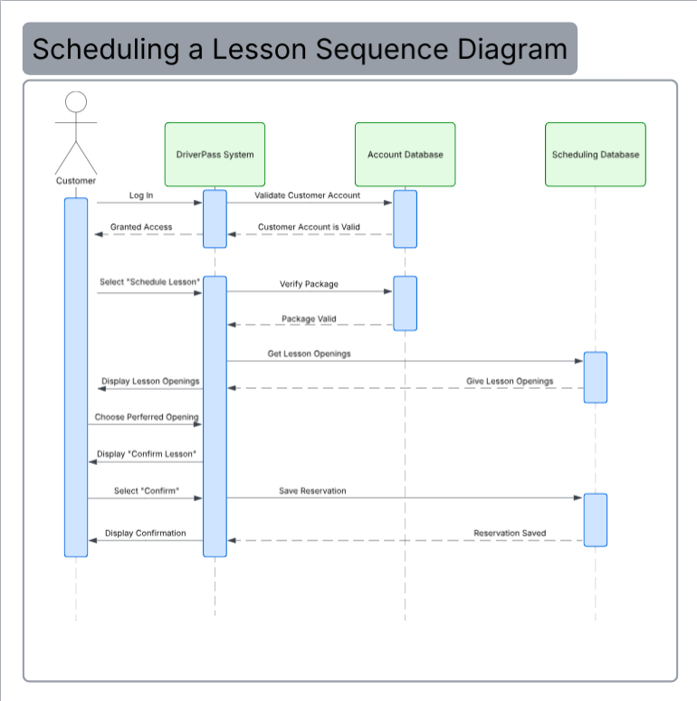

UML Class Diagram
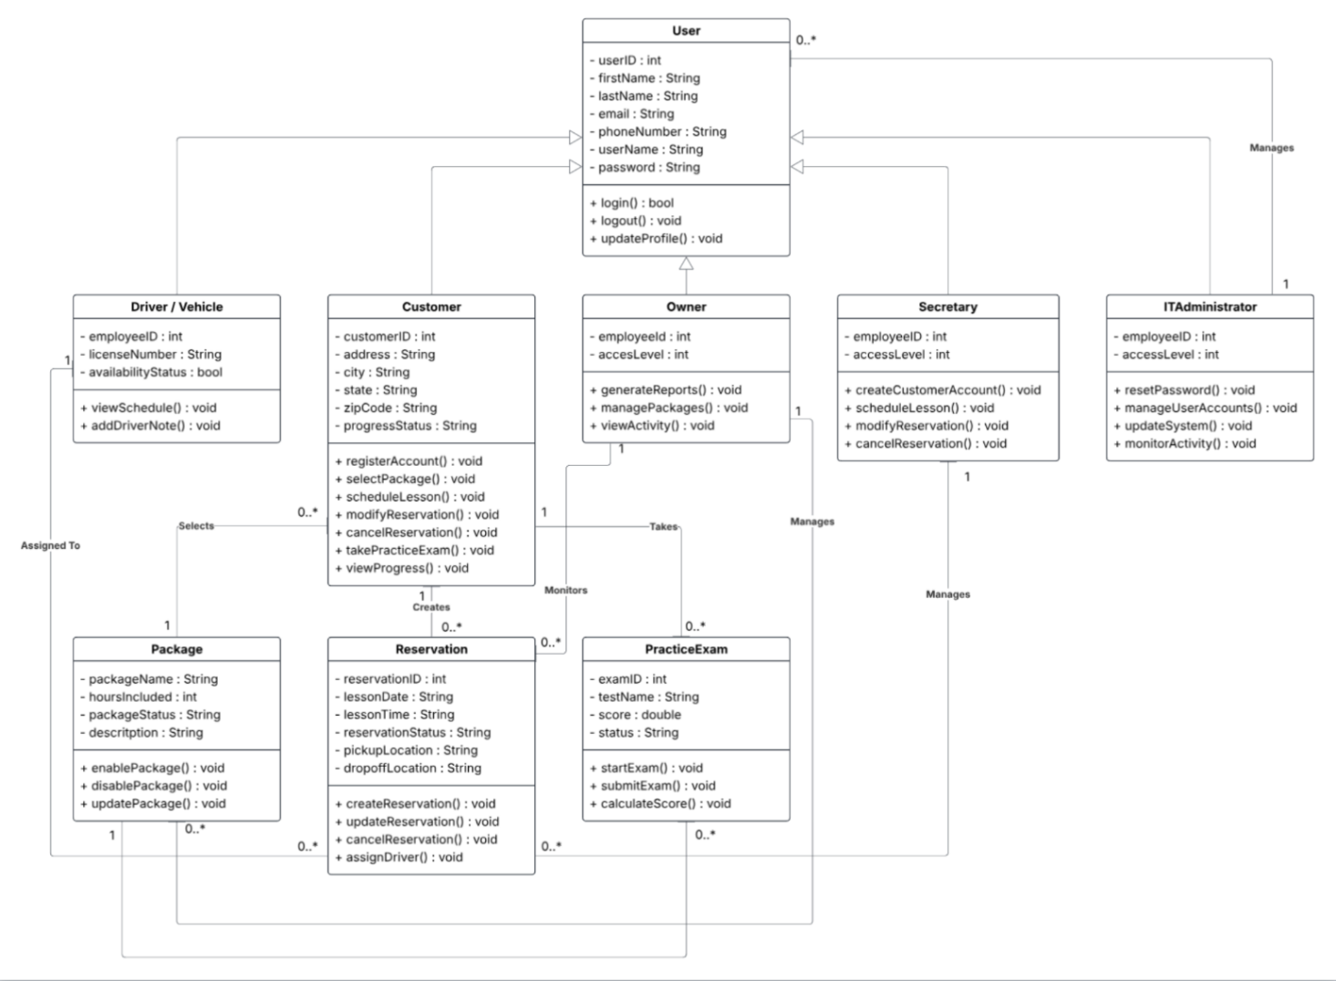

Technical Requirements
There was no mention of any hardware specifications in this project, or how the DriverPass website and databases should be hosted. It would be my best recommendation to use AWS Cloud database instances and web hosting to save on the costs of an on-premises data center. This will alleviate the need to spend money on servers that may be under or overpowered for what the site and databases need. AWS Cloud is scalable and offers “pay-as-you-go” which would be my recommendation to use as we do not know the exact scale the traffic may use. Since we are going to cloud-hosted, there will be no need for on-premises servers, the system will rely on AWS-managed infrastructure and user endpoint devices.
- Hardware Requirements:
- End-point devices such as desktop / laptop for secretaries, owners, and IT administrators to access the DriverPass application. Mobile devices for customers and instructors to review schedules, notes, and practice exam progress
- Reliable internet access for all users interacting with the system. Secure office network connectivity for DriverPass staff, and firewall / router protection for any office-based admin access
- AWS-managed compute, storage, database, and additional services infrastructure hosted on the cloud

- Software Requirements:
- Web-based DriverPass application accessible through standard web browsers
- Responsive front-end interface for desktop and mobile devices
- AWS cloud servers running a server operating system (Linux, Windows, etc.)
- Database software like the mentioned Amazon RDS to store things like customer information, user credentials, packages, etc.
- Security access management controls though AWS and application-level authentication
- Encryption software and secure connection protocols to protect sensitive data

- AWS Cloud Infrastructure Requirements:
- Amazon EC2 instances compute service to host the DriverPass web application and business logic
- Amazon RDS to provide a managed and relational database environment that features automated backups, database patching, and failover support that is managed by AWS and will store things like user account data, lesson scheduling and reservations, training packages, and practice test data
- Amazon S3 for storing important data like generated reports, exported files, system documentation and other non-database content. Great for secure cloud storage for backups and archive records
- Additionally, we can use the AWS service CloudWatch to track system metrics like performance, and will also log user activity, system events, and administrative actions

